**Technology Demonstration Interface**

1. **Home Page.**

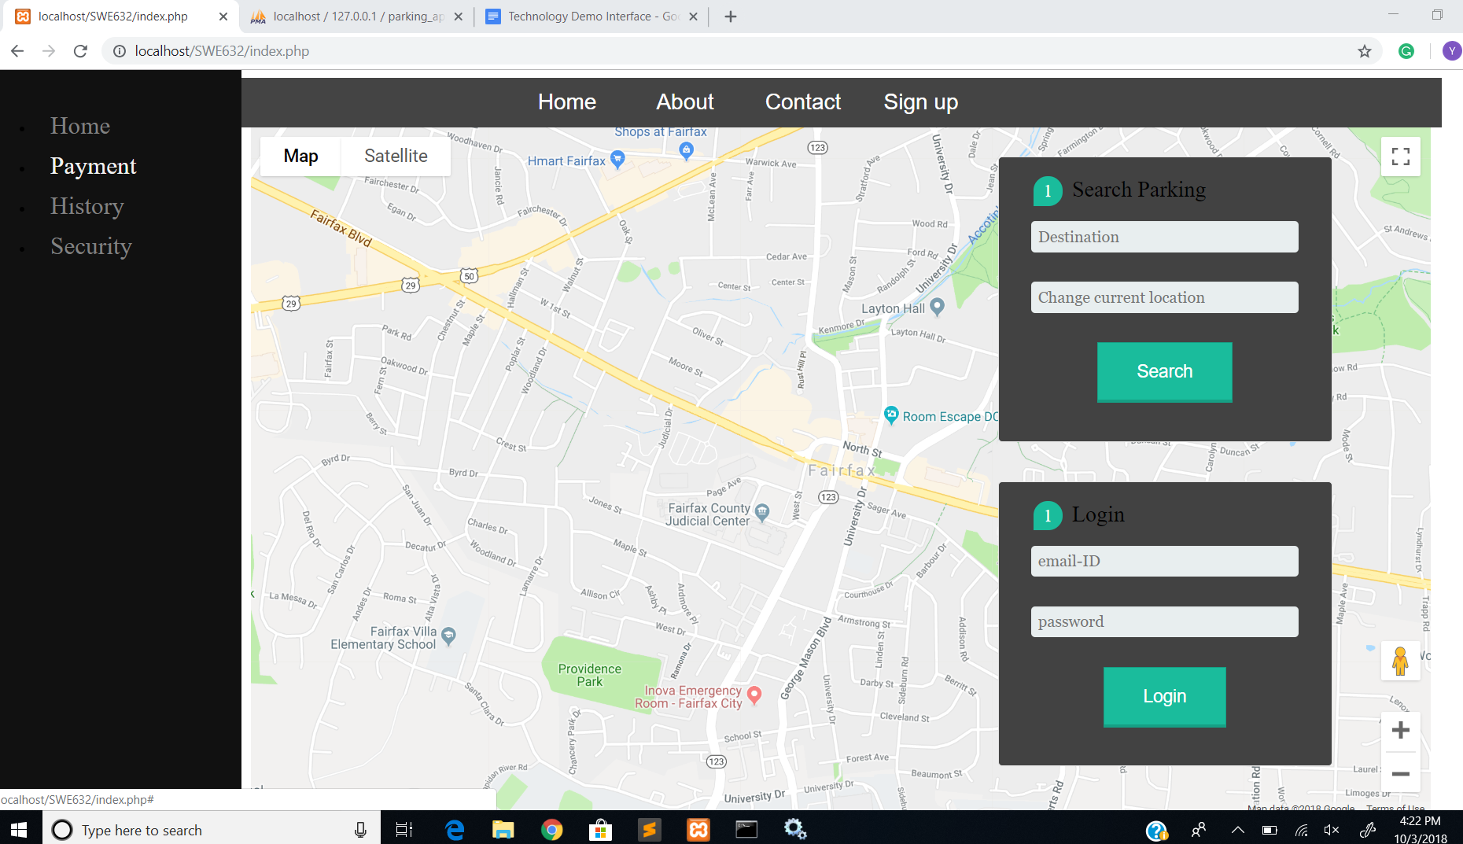

**2) Database (My SQL)**

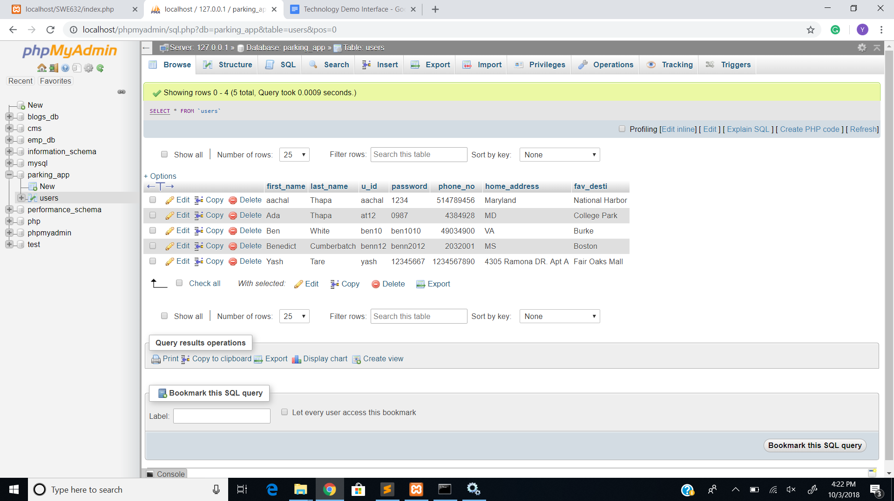

**3) Login Failed**

